Analytic Plan for ABC Hotels Cancellation Probability Prediction
  - Ryan Waterman

Table of Contents
Business Problem Statement 3
Dataset Overview and Exploratory Data Analysis 3
Initial Variable Selection Strategy 7
Preliminary Modeling Strategy 8

Business Problem Statement
ABC Hotels, a prominent hotel chain, has a booking platform that allows customers to book stays at the hotel in advance. The booking platform has generated a boost in revenue since its implementation, but has posed an additional problem: cancellation. A cancellation poses several problems: lost revenue, potential vacancy due to late cancellation, and overstaffing. Based on the existing booking data, ABC Hotels would like to implement a cancellation probability prediction model. The goal would be to identify customers that have a high probability of cancelling their stay, then developing a strategy to retain them. This strategy could include additional advertisements or bonus offers incentivizing them to complete their stay. This strategy could even extend to future stays, creating returning customers.

Dataset Overview and Exploratory Data Analysis
The data set provided by ABC Hotels includes 17 variables and 36,238 observations. Of the 17 variables, 11 are quantitative, and 6 are categorical, as seen in the table, below. Note that ‘Booking_ID’ and ‘arrival_date’ are not associated with quantitative or categorical classification. This is intentional, as these variables are unique identifiers for each of the bookings in the dataset. They do not provide predictive value for future observations. The variable ‘booking_status’ is the target dependent variable for the model to predict.
Variable Name | Classification
no_of_adults | Quantitative
no_of_children | Quantitative
no_of_weekend_nights | Quantitative
no_of_week_nights | Quantitative
required_car_parking_space | Quantitative
lead_time | Quantitative
repeated_guest | Quantitative
no_of_previous_cancellations | Quantitative
no_of_previous_bookings_not_canceled | Quantitative
avg_price_per_room | Quantitative
no_of_special_requests | Quantitative
type_of_meal_plan | Categorical
room_type_reserved | Categorical
market_segment_type | Categorical
booking_status | Categorical

The categorical variables are distributed according to the histogram plots, below:
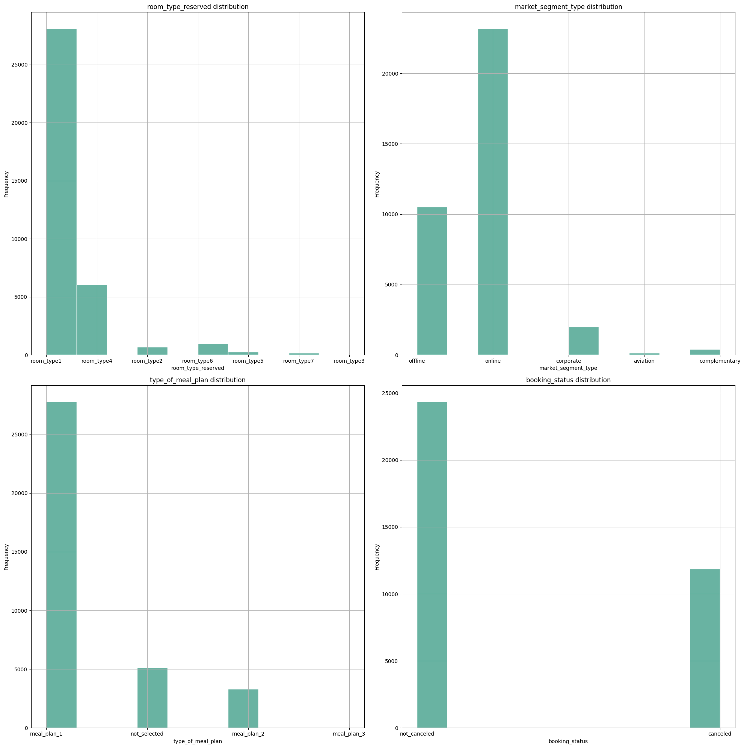
Chart 1: Histogram Plots of Categorical Variables

Of the variables that were identified as being correlated, the charts, below, indicate the most positive and the most negative correlated variables, respectively:
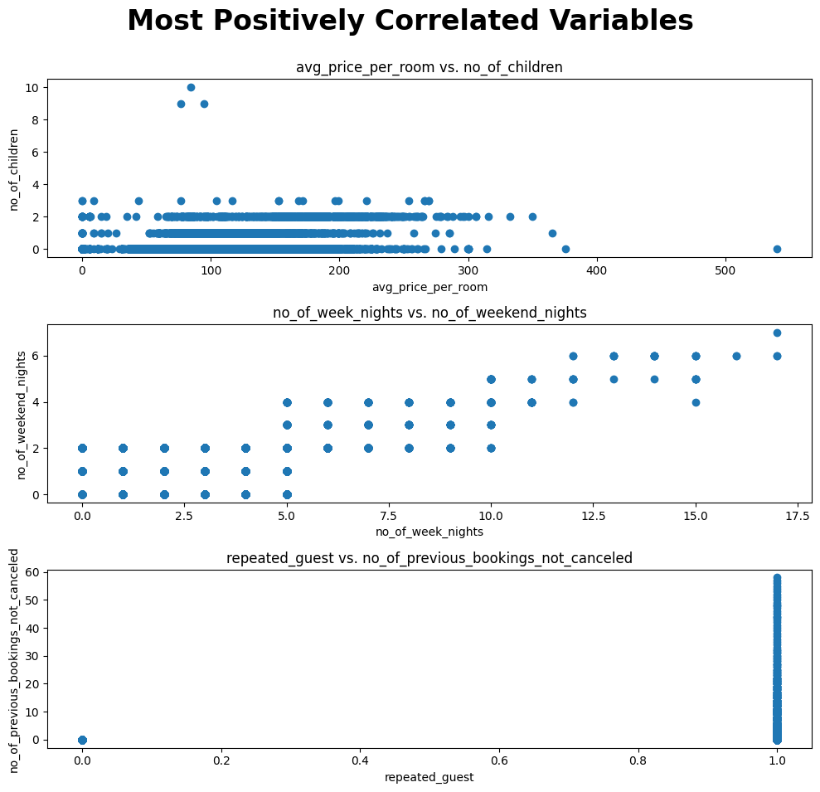
Chart 2: Most Positive Correlated Variables
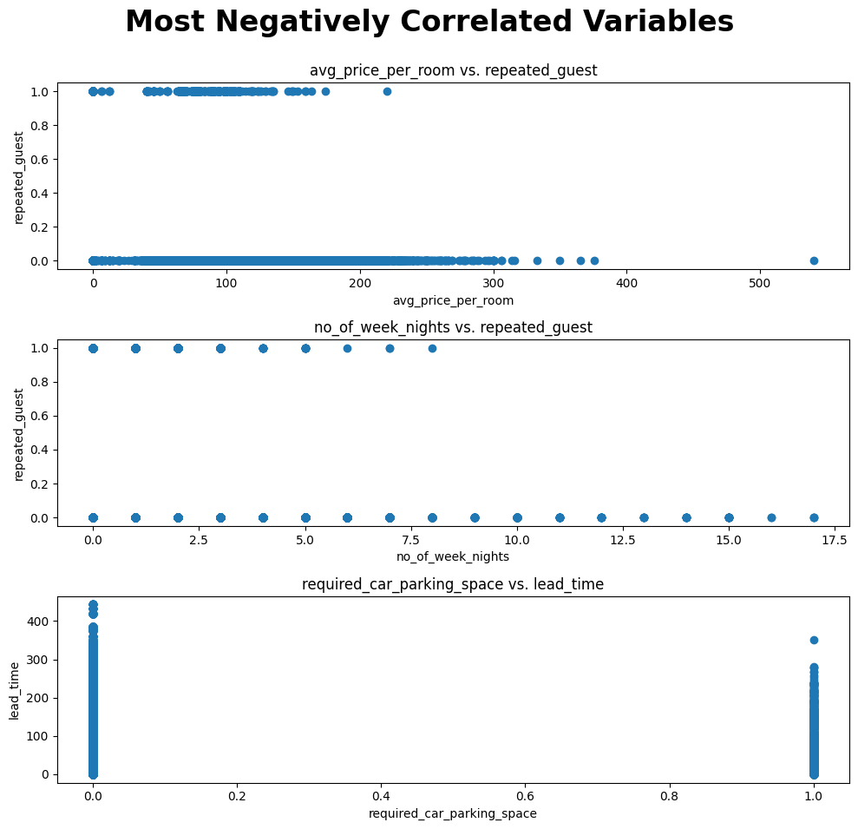
Chart 3: Most Negative Correlated Variables
The correlation between the variables identified in charts 2 and 3 indicate that there are no clear trends within the data set. A deep neural network is a good candidate to learn possible high-dimensional interactions between the variables. Deep neural networks excel in learning to predict data that do not have clear relationships.

Initial Variable Selection Strategy
For the preliminary testing, all variables will be included. After training a naïve model, stepwise variable selection can be used to reduce the number of variables used during more sophisticated model training. See the variable selection table, below:
Variable Name | Classification
no_of_adults | Quantitative
no_of_children | Quantitative
no_of_weekend_nights | Quantitative
no_of_week_nights | Quantitative
required_car_parking_space | Quantitative
lead_time | Quantitative
repeated_guest | Quantitative
no_of_previous_cancellations | Quantitative
no_of_previous_bookings_not_canceled | Quantitative
avg_price_per_room | Quantitative
no_of_special_requests | Quantitative
arrival_month | Quantitative
meal_plan_not_selected | Quantitative
meal_plan_1 | Quantitative
meal_plan _2 | Quantitative
meal_plan _3 | Quantitative
room_type1 | Quantitative
room_type2 | Quantitative
room_type3 | Quantitative
room_type4 | Quantitative
room_type5 | Quantitative
room_type6 | Quantitative
room_type7 | Quantitative
offline | Quantitative
online | Quantitative
corporate | Quantitative
aviation | Quantitative
complementary | Quantitative

Additional variables could be generated to increase non-linearity in the data. These variables could be log transformed combinations of the initial quantitative variables, for example. Variables such as room cost, repeated guests, number of previous cancellations, and number of special requests are candidates for transformation. The feature generation process will be entirely experimental, each time training the naïve model with all variables, as well as the new, transformed variables, included. The metrics, detailed in the preliminary modeling strategy, will be used to evaluate if the inclusion of transformed variables improved the model, as compared to the naïve model with only the initial variables.
Based on the histogram plot for booking_status, class imbalance is a factor that will need to be corrected. Class imbalance could be addressed by randomly sampling a smaller subset of the ‘not cancelled’ observations. If the model evaluation steps detailed in the Preliminary Modeling Strategy indicate that class imbalance is an issue (i.e. high density false positives or false negatives on a particular booking_status outcome), then the ratio of ‘not cancelled’ observations could be further reduced.

Preliminary Modeling Strategy
A custom deep neural network will be deployed for the prediction task. Each iteration of the model architecture will be evaluated based on the following criteria:
- Accuracy on Novel Data (Cross Validation)
  - This will be evaluated by excluding data from the training data set. The same data will be excluded from the training data for each iteration of the model to remain consistent.
- Recall
  - After the model makes predictions on the test data, a confusion matrix will be generated for each model. Recall will be calculated based on the ratio of true positives to the total number of actual positives.
- Precision
  - The proportion of positive predictions that are actually positive.
- F1-score
  - The harmonic mean of precision and recall (2 * (Precision * Recall) / (Precision + Recall)).
Some of challenges that could arise during this initial modeling attempt would be none of the models making accurate predictions, including the categorical variables in the dataset, and evaluating the quality of the dataset. If the model cannot converge and make accurate predictions, there are two approaches to take. First, the hyperparameters of the model could be tuned, and second, the dataset could be modified. This leads to another challenge: evaluating dataset quality. This is something that will be addressed regardless of the model performance. The intent would be to use multiple linear regression (MLR) to evaluate the interaction between variables and get a general sense of the relationship between the predictors and booking_status. If the MLR is used as the baseline for dataset viability, then changes to the dataset could be evaluated using the same criteria to determine the impact on the custom model.
The model is expected to output a cancellation probability, which is a well-suited outcome for a supervised deep neural network. The model will output a probability of the dependent variable classes by default, from which the cancellation probability can be extracted. In practice, a threshold could be set for cancellation probability that merits additional advertising or bonus offers.

